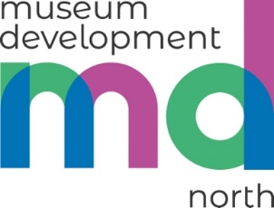
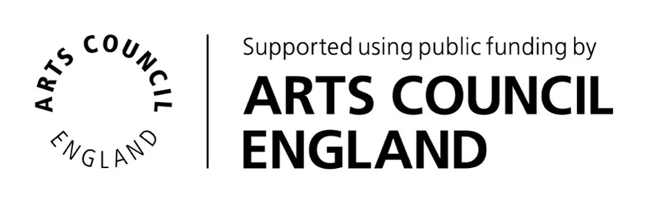

CPD Bursary 2024-25 Guidance Notes

1. Museum Development North CPD Bursary

These Guidance Notes explain how you/your museum can apply for a Continuing Professional Development (CPD) Bursary in 2024-25 to support your personal development and the development of employees, volunteers and freelancers.

Thanks to funding from Arts Council England and with support from Art Fund, MD North can offer CPD bursaries for individuals, organisations and networks in the North of England that represent or work with Accredited museums and museums officially Working Towards Accreditation.

1.1 Priorities of the scheme
This grant scheme is being made available to support the museum sector to retain and train its workforce.
Applications for funding must support one of three key aims:
- Develop the use of collections in new ways

- Support audience development and increase engagement with under-represented audiences

- Volunteer and workforce development including:

- Staff and volunteer retention and training.
- Support for activity to ensure museums can keep curatorial and other collection-centred roles (including collection care, learning and engagement).
- Support for in-house training and places on training courses and conferences.
- Wellbeing offers for staff and volunteers.
- Bespoke personal development opportunities to upskill collection and curatorial staff.
- Support for new and existing museum networks and partnerships for skills sharing and development of the workforce.

Additional consideration will be given to applications from:

- museums with fewer than 50,000 visitors per year seeking to reconnect with visitors or reimagine their future as vital community spaces.

- museums in areas of low cultural community engagement, where the museum is the main cultural offer in a locality.

- museums in urban areas that have niche collections and specific cultural offers outside the larger city institutions.

1.2 Funding available

Grants of up to £500 are available for individual activity.
Museums, museum networks and partnerships can apply for up to £2,000 for activity benefiting more than one participant.
Higher awards will be made for applications benefiting more than one individual, or where higher costs are essential to the project, e.g. international CPD opportunities.

In addition to paying for development opportunities, such as training and conference places, bursaries can also cover costs for:

- Travel, accommodation and subsistence:
  - Standard fare public transport or £0.45 per mile where cost is incurred – MD North expects that public transport be used wherever possible.
  - Accommodation at £120 per day.
  - Subsistence at £50 per day.
- Reasonable adaptation costs for accessibility or care.
- Reasonable costs associated with caring for dependents e.g. respite care, out-of-hours childcare or other dependent care.

The bursary cannot be used to cover core staff salary costs but can be used to backfill staff undertaking CPD activity.

1.3 What the CPD Bursary can be used to support

A bursary can be used to develop the knowledge, skills and behaviours of people employed/contracted by/working with or volunteering in museums in the north of England, that reflect the needs of the museum/s in the North region.

If a bursary is supporting an employee’s CPD, this must form part of their working hours and not be unpaid overtime.

Applications for a bursary must be approved by the appropriate manager or decision-making group within the museum, network or partnership.

This bursary is intended to benefit museum organisations and is not open to applications from individuals for activity which is entirely unrelated to their work, or volunteering activity outside of the north of England.

Other sources for funding for personal and professional development includes membership organisations like the Museums Association or the Association of Independent Museums. For more substantial programmes of personal professional development, we recommend Developing Your Creative Practice from Arts Council England.

Projects could include; taught or instructor led sessions such as lectures, workshops, courses, online learning and conferences and practical training such as shadowing, mentoring, industry visits. You may be aware of other development opportunities which you feel fit with the aims of the scheme, please get in touch to discuss.

The bursary cannot be used to cover core staff salary costs but can be used to backfill staff undertaking CPD activity.

2. How to apply

2.1 Eligibility

The CPD Bursary is open to:

- Individuals (including volunteers and freelancers) who work in and with museums in the North of England.

- Organisations operating museums that are:
- Accredited with Arts Council England or
- Working Towards Accreditation with Arts Council England and
- Located in the north of England

The CPD Bursary is not open to individuals or organisations where the museum:
- receives funding from Arts Council England as National Portfolio Organisations (NPOs) or
- receives funding from the Department of Culture, Media and Sport (DCMS) as National Museums

Museums that are non-lead members of an NPO partnership/consortium may be eligible to apply. Projects that involve NPO museums alongside other museums may be able to apply. For any projects that involve NPO museums, please speak to your Museum Development Adviser before applying to discuss eligibility.

2.2 What to consider before applying

Before applying:

- Discuss your planned application within the organisation, network or partnership you are affiliated with to identify others who may want to apply, as we are unlikely to award more than one bursary per year to the same organisation.
- Consider talking to MD North before applying. We would welcome a conversation with you. Please contact your Museum Development Adviser.

In your application:

- Show how the funding will support your professional development and/or help the museum, network or partnership achieve the aims of this grant fund.

- Show how the project is aligned with ACE’s Investment Principles Investment Principles Resource Hub | Arts Council England.

- If appropriate, review any documents (e.g. your Forward or Business Plan, Accreditation Award letter or external review) and identify how the bursary addresses any recommendations and will make an impact on your work.

2.3 Application form and questions

Make your applications for a MD North CPD Bursary via:
https://online1.snapsurveys.com/fat3u1

You will be asked:
- What the CPD opportunity or project is, including details of the course or opportunity if relevant.
- How it meets one of the three key aims of the scheme.
- How it would help meet the needs of and benefit the individual and/or organisation, network or partnership, and how you can evidence this.
- How the activity will deliver against ACE’s Investment Principles.
- Cost of activity, value of match funding or in-kind support, and amount of funding requested from MD North.
- Timing of the activity.
- If you are a freelancer, we will ask you to provide details of a museum in the North that you have worked with.

If you are applying for a bursary and need support to complete the application form, please contact Sue Hughes: sue.hughes@museumdevelopmentnorth.org.uk. If you have additional needs, we will support you to complete a draft of the application for you or another colleague to review.

Applications will be assessed on a rolling basis until 6th December 2024.

**Please note the CPD Bursary will close earlier if all funds have been allocated.**

Grants awarded must be claimed by 28th February 2025.

2.4 Decisions on applications

All applications will be assessed within two weeks by the MD North team.

Decisions will be made on an assessment of need and viability.

2.5 Cash and in-kind contributions

We believe that museums should invest in their staff and volunteers where possible. Match funding is therefore welcome in all applications when applying for a CPD Bursary for wider staff development within the organisation. Match funding from other Art Fund or Arts Council England grant schemes are not eligible.

2.6 How payments are made

The CPD Bursary will usually be paid to the museum upon completion of the project. Grants are paid following receipt of a claim form with evidence of expenditure and evaluation of the project.

Please contact us if you or your organisation need to discuss payment in advance to support cashflow. Requests will be considered.

We also expect short case studies to be submitted, using a template provided by MD North, that could be presented at a forum meeting, Elevenses session or shared on our website.

2.7 Applications for multiple CPD bursaries

It is unlikely that any organisation will receive more than one bursary per financial year.

2.8 Conditions of support

MD North operates using funding from Arts Council England, and, for this fund, with support from Art Fund. We place conditions on our investment so that we can show the value of our work and evidence the impact to our funders and stakeholders.

Each formal offer of support will require your museum to agree to the conditions of the award. You will be asked to:

- Demonstrate accountability for public funds: Monitor project progress and undertake an evaluation of the impact of our investment and extent to which the project has achieved its aims.
- Celebrate success: Promote your activity and support MD North in making stakeholders aware of the benefits of museums delivering better services in more sustainable ways.
- Acknowledge MD North support: You will need to acknowledge the support of MD North where appropriate. Acknowledgement could take the form of:
  - Including MD North in a list of funders and supporters.
  - Including MD North in internal and external publicity and reports as appropriate.
  - Reference to MD North on your website, digital materials and social media feeds as appropriate.
A pdf, jpeg or eps file of the MD North and ACE logos is available via email.
- Acknowledge Art Fund: When sharing information about the project, you must use the credit line “with Art Fund support” and where possible the Art Fund logo, which will be made available to you.
- Share learning: Share what you, your museum, network or partnership has done and learned across the north of England so that others can also benefit from the investment. If asked, we will expect you to host visits or placements, provide case-studies and present content at regional meetings.
- Embed change: Your museum is expected to show how you have used this investment to address specific challenges or opportunities and move forward. The programme’s focus is on developing museums so that they continue to evolve and deliver more effective and efficient services for their audiences.

Failure to meet these conditions of support may result in the termination of support and the reallocation of resources. Any such outcome will be used to inform future investment priorities.

2.9 If unable to go ahead
If the CPD Bursary opportunity or project is unable to be used, please let us know as soon as possible so that we can re-allocate resources.

If a proposed attendee is unable to complete the CPD opportunity, we would expect another employee or volunteer to attend in their place. Only in exceptional circumstances would a bursary be paid to a museum to cover the costs of non-attendance.

2.10 About the funding

MD North CPD Bursary 2024-25 is made possible with support from Art Fund www.artfund.org.

Museum Development is part of a national programme of funding from Arts Council England, which supports and enables this grant scheme Museum Development programme | Arts Council England.

MD North has been commissioned to deliver Arts Council England’s Strategy 2020-2030, Let's Create | Arts Council England.

